1. Install and run **Loopback.app (**[**https://rogueamoeba.com/loopback/**](https://rogueamoeba.com/loopback/)**)**
2. Make a new virtual device and set your **browser** as the audio source   
   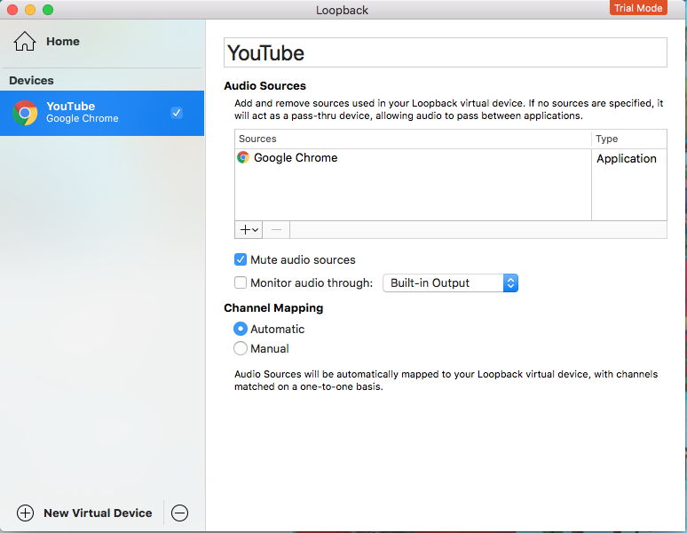
3. In miniAudicle, set Audio **Input** to the virtual device  
   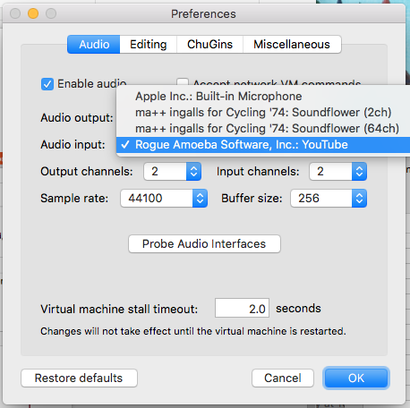
4. Once you start the virtual machine, the audio from your browser should be muted. (since now it is routed to miniAudicle).
5. Download all the files in our folder. Videos.txt contains links to Youtube videos that will be your sound sources.
6. Run one of the chuck files starting with an underscore in miniaudicle and then play your Youtube video. Press any key to trigger your sounds. Use the maui window to control parameters of your sound.
   1. Bass: you can trigger the sound by pressing any key.
   2. Autotune: First two autotune is set to certain chords. Others shift pitch.
   3. Robotic: Amplitude Modulator
   4. Filters: you can adjust the frequency settings of various filters
7. Conductor will walk around to give additional instructions.
8. Everybody turn your speakers off now!

<https://www.youtube.com/watch?v=ucqXECc8tmc>

<https://www.youtube.com/watch?v=12KzmiG4JEg&t=64s>

<https://www.youtube.com/watch?v=mp28JPs25ek&list=LLXoRmIp3LRJ9ZuK1BSWdSUw&index=180>

<https://www.youtube.com/watch?v=y9K18CGEeiI&list=LLXoRmIp3LRJ9ZuK1BSWdSUw&index=171>

<https://www.youtube.com/watch?v=8Y4CwqdEsgI>

<https://www.youtube.com/watch?v=fW4r_ioMojQ>

<https://www.youtube.com/watch?v=1eOaI6wSP5E&index=97&list=LLXoRmIp3LRJ9ZuK1BSWdSUw>

<https://www.youtube.com/watch?v=qPZymccwZm4&list=LLXoRmIp3LRJ9ZuK1BSWdSUw&index=154>

<https://www.youtube.com/watch?v=SKft_J3YezE>

<https://www.youtube.com/watch?v=LZgeIReY04c&index=76&list=LLXoRmIp3LRJ9ZuK1BSWdSUw>

<https://www.youtube.com/watch?v=GGBKRegfON8&list=LLXoRmIp3LRJ9ZuK1BSWdSUw&index=40>

<https://www.youtube.com/watch?v=toVK97H4j24&index=31&list=LLXoRmIp3LRJ9ZuK1BSWdSUw>

<https://www.youtube.com/watch?v=0Dpw0VvH4m0&index=29&list=LLXoRmIp3LRJ9ZuK1BSWdSUw>

<https://www.youtube.com/watch?v=B5JRf3dIPJ4&t=101s>

**LIVE:** [**https://www.youtube.com/watch?v=9Q6nDGnQryQ**](https://www.youtube.com/watch?v=9Q6nDGnQryQ)